|  |  |
| --- | --- |
| **Date** | **28 June 2025** |
| **Team ID** | **LTVIP2025TMID30062** |
| **Project Name** | **Sustainable Smart City Assistant Using IBM Granite LLM** |
| **Maximum Marks** | **2 Marks** |

**Sustainable Smart City – AI-Powered Python-Based System**

# Technical Architecture

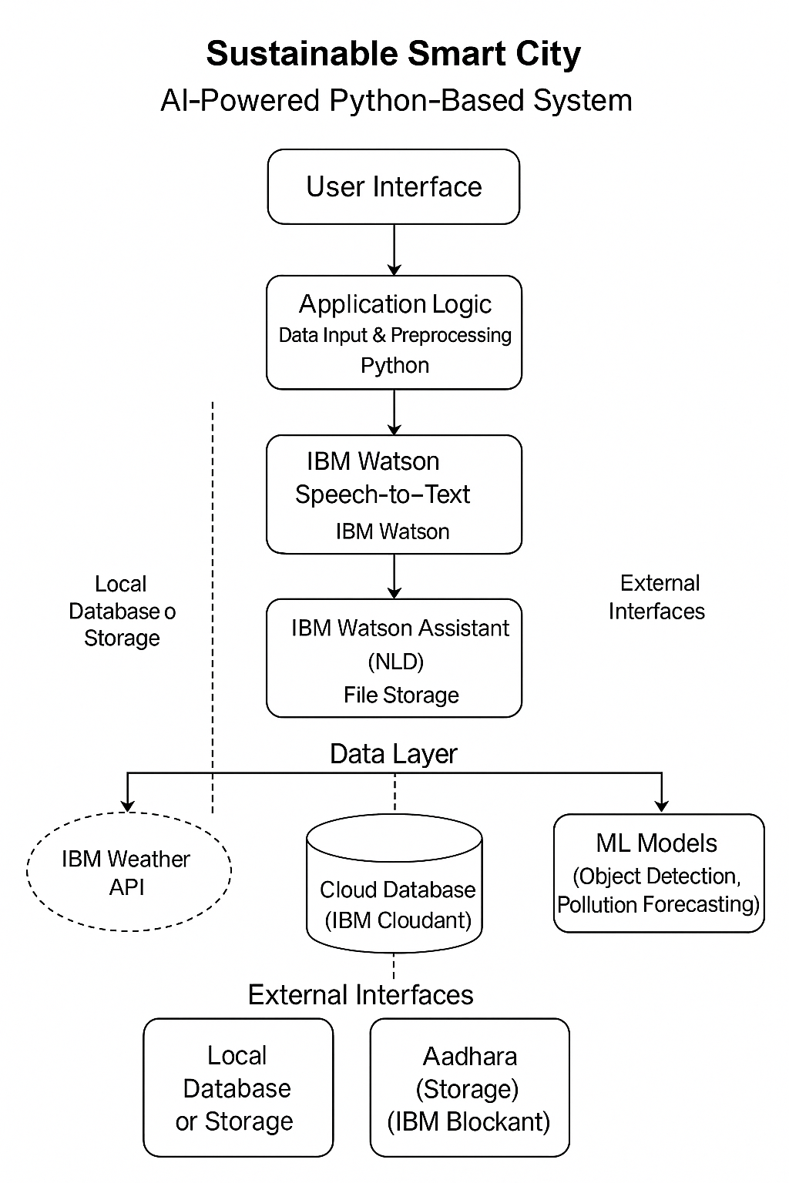The system is designed as a cloud-enhanced, AI-powered application focusing on sustainability and smart city operations.

# Table 1: Components & Technologies

|  |  |  |  |
| --- | --- | --- | --- |
| 9 | External API-2 | Identity verification | Aadhaar API |
| 10 | Machine Learning M | odelObject detection, Pollution level prediction | TensorFlow / IBM Watson ML |
| 11 | Infrastructure | Deployment on cloud or local | IBM Cloud / Kubernetes / Docker |

|  |  |  |  |
| --- | --- | --- | --- |
| **S.No** | **Component** | **Description** | **Technology** |
| 1 | User Interface | Web/Mobile/Chatbot interface | HTML, CSS, JS, React |
| 2 | Application Logic-1 | Smart City Functions (Alerts, Monitoring) | Python |
| 3 | Application Logic-2 | Voice input to text | IBM Watson STT |
| 4 | Application Logic-3 | NLP + Chatbot for citizen interaction | IBM Watson Assistant |
| 5 | Database | Local data storage | MySQL |
| 6 | Cloud Database | Cloud-based structured and unstructured st | orageIBM Cloudant |
| 7 | File Storage | For media, logs, and documents | IBM Block Storage, Local FS |

# Table 2: Application Characteristics

|  |  |  |  |
| --- | --- | --- | --- |
| **S.No** | **Characteristics** | **Description** | **Technology** |
| 1 | Open-Source Framework | s Libraries for frontend/backend | Flask, React, TensorFlow, Node.js |
| 2 | Security Implementations | IAM, Authentication, API Tokens, Encryption | SHA-256, OAuth2, SSL, JWT |
| 3 | Scalable Architecture | Microservice-based, can be containerized f | or flexibilityKubernetes, Docker, REST APIs |
| 4 | Availability | Load balancing & failover across cloud zon | es |
| 5 | Performance | CDN, Caching, optimized API response | Redis, Cloud CDN, Async APIs |

# References

https://c4model.com/

https://developer.ibm.com/patterns/ai-powered-backend-system-for-order-processing-during-pande mics/

https://www.ibm.com/cloud/architecture https://aws.amazon.com/architecture

https://medium.com/the-internal-startup/how-to-draw-useful-technical-architecture-diagrams-2d20c 9fda90d